Caravan Park (Interim) Fire

Safety Guideline

**Guideline No.** 51 (Interim)

**Author:** Fire Safety Strategy and Policy

**Sponsor:** Building Inspection and Compliance

**Authorised by:** Director, Fire Safety

**Approval level:** Fire Safety

**First issued:** 15 January 2021

**Review date:** 26 March 2021

**Version number:** 1.1

Table of Contents

Foreword by the Deputy Fire Rescue Commissioner 2

1 INTRODUCTION 3

2 DEFINITIONS 4

3 BACKGROUND 6

4 KEY STAKEHOLDER RESPONSIBILITIES 7

4.1 Caravan Park Owners 7

4.2 Local Council 7

4.3 FRV, CFA and other Emergency Services 7

5 GUIDELINE STRUCTURE 9

5.1 Objectives (O) 9

5.2 Performance Measures (PM) 9

5.3 Prescriptive Provisions (PP) 10

6 APPLICATION OF THE GUIDELINE 11

6.1 Using the Guideline Structure 11

6.2 Complying with Prescriptive Provisions 12

6.3 Demonstrating Compliance with Performance Measures 12

6.4 The Alternative Solution process 13

6.5 Preparing the Brief 13

6.6 Required Documentation 14

7 UNDERSTANDING FIRE BRIGADE INTERVENTION 17

7.1 What is Fire Brigade Intervention? 17

8 WHO CAN PROVIDE PROFESSIONAL ADVICE? 18

9 Applying the Guideline to Proposed and Existing Caravan Parks 19

10 OBJECTIVES 21

11 PERFORMANCE MEASURES 22

12 PRESCRIPTIVE PROVISIONS 25

13 OTHER GUIDANCE INFORMATION 43

13.1 Provisions for Maintenance 43

13.2 Specific Advice on Smoke Alarms (Regulation 36) 44

13.3 Maintenance and inspection records 44

13.4 Maintenance Inspection Frequencies 45

14 CHECKLIST 48

15 REFERENCES 51

# Foreword by the Deputy Fire Rescue Commissioner

Whether they’re in small coastal town or near a big city, caravan parks are an iconic part of the Australian landscape. Right across Victoria, they provide short-term and long-term accommodation in self-contained cabins, powered sites and tent site for campers. They also provide residential villages for permanent living, which offer a strong sense of community.

The purposes and needs of caravan parks vary greatly across the state – and therefore, so too do the fire safety risks and resources. This guide aims to reduce the likelihood and consequence of fire within a caravan park.

The latest edition of the guideline addresses ongoing needs within those communities, including stakeholders, to form a flexible and practical fire safety resource.

It includes information to make site specific fire safety improvements in parks, and additional guidance on topics like maintenance of fire safety systems.

Fire Rescue Victoria (and the Country Fire Authority) recognise that what works for one caravan park operator may not work for another, and this guideline has been developed with flexibility in mind.

It is important that all those with responsibilities in owning, managing and operating caravan parks – large or small – are fully aware of and understand, their responsibilities and obligations in understanding fire safety within caravan parks.

Aside from the obvious community safety imperatives, having a well-considered fire safety plan is a good risk-management business decision. We encourage owners and operators to consider the information in this guideline and work together to maintain and develop their fire safety strategies.

I encourage you to use this information to make sure that as an owner or operator of a caravan park, you are doing all you can to ensure the safety of your communities, and so future generations can continue to use your wonderful parks and facilities.

Michelle Young AFSM

Deputy Fire Rescue Commissioner

Fire Safety

# INTRODUCTION

This (Interim) Fire Safety Guideline has been jointly developed by the Country Fire Authority (CFA) and Fire Rescue Victoria (FRV) to provide a uniform set of technical provisions for the design, construction and maintenance of caravan parks throughout Victoria whilst allowing for site specific variations due to geographical conditions or individual site constraints. These provisions will enable the achievement of consistent, minimum and necessary provisions for fire safety and emergency management within caravan parks. These provisions have been developed so that the requirements generate net benefits to society greater than the costs. The competitive effects of the requirements have been considered and the provisions are no more restrictive than necessary in the public interest.

This guideline can be applied to both existing and proposed caravan parks and can be used as a reference tool in relation to fire safety for—

* Caravan park owners and occupants;
* Local government;
* Designers; and
* FRV and CFA employees.

To ensure a consistent approach is applied statewide, regardless of the site, the guideline requires the following six objectives to be met:

**O1 Provision and Maintenance of Access**

**O2 Prevention of Fire Spread**

**O3 Provision and Maintenance of Firefighting Equipment**

**O4 Identification and Management of Fire Hazards**

**O5 Development and Implementation of Emergency Management Plans**

**O6 Compliance with Legislative Requirements**

The user may demonstrate that they have satisfied these objectives by meeting the performance measures, prescriptive provisions or a combination of both. This approach gives the guideline a degree of flexibility that was not previously available and enables the objectives to be met regardless of the situation, be it existing or proposed.

Whilst the performance measures allow for development of site-specific fire safety provisions, their application relies upon the user demonstrating a considered approach based on ISO 31000 international standard (published in 2009) that provides principles and guidelines for effective risk management.

Appropriate application of this guideline requires consultation with FRV and CFA, including other authorities, such as Energy Safe Victoria for the requirements of gas and electrical safety. This, combined with a suitable awareness of fire safety matters, will facilitate compliance with existing legislative responsibilities and the fire safety requirements in relation to caravan park fire safety.

# DEFINITIONS

For the purpose of this document, the following definitions and abbreviations will apply.

***Appropriate*** means—

Will perform as required relevant to the specific issue to achieve the desired outcome.

***Caravan Park*** as defined by the *Residential Tenancies Act 1997*.

“An area of land on which movable dwellings are situated for occupation on payment of consideration, whether or not immovable dwellings are also situated there.”

This Guideline applies to Caravan Parks only. Residential villages, Retirement villages or the like are referred to the fire services separately in accordance with Sections 52 or 55 of the Planning and Environment Act 1987 and accordingly different fire safety requirements apply.

***Caravan / Movable Dwelling / Tent*** as defined by the Residential Tenancies Act 1997.

“A movable dwelling; or an immovable dwelling situated in a caravan park.”

***CFA*** is the acronym that is used to identify the Country Fire Authority.

The relevant fire authority for the purposes of the Residential Tenancies (Caravan Parks and Movable Dwellings Registration and Standards) Regulations 2020 within the country area of Victoria.

The country area of Victoria is defined by the *Country Fire Authority Act 1958* as “means that part of Victoria which lies outside the Fire Rescue Victoria fire district, but does not include any forest, national park or protected public land.”

***Degree Necessary*** means—

To the extent that is required to fulfil the function.

***DELWP*** is the acronym that is used to identify the Department of Environment, Land, Water and Planning.

Responsible for the development and implementation of the Residential Tenancies (Caravan Parks and Movable Dwelling registration and Standards) Regulations 2020 as amended from time to time.

***FRV*** is the acronym that is used to identify Fire Rescue Victoria.

The relevant fire authority for the purposes of the Residential Tenancies (Caravan Parks and Movable Dwellings Registration and Standards) Regulations 2020 within the Fire Rescue Victoria fire district.

***Qualitative*** means—

An argument based on comparative reasoning i.e.: expert judgement or opinion.

***Quantitative Argument*** means—

An argument based on numerical analysis i.e.: design computations or data.

***Relevant Fire Authority*** means—

Fire Rescue Victoria (FRV) or the County Fire Authority (CFA).

***Relevant Fire Authority Staff*** means—

An FRV or CFA employee representing the relevant fire authority on fire safety matters.

***Site*** means—

Any place within the perimeter of the caravan park including those occupied by structures.

***Structure*** means—

Includes a caravan, movable dwelling, unmovable dwelling, tent or an ancillary/service building.

Note: For firefighter access and fire separation purposes, tents need only be separated by rented site rather than individually within a single rented site.

***Suitably Trafficable*** means—

Paved, sealed or hardened surface that is relatively even and continuous for pedestrian access.

This may include concrete, bitumen, grass or gravel etc. but excludes garden beds or other inappropriate surfaces for people to walk on.

***The Act*** means the Residential Tenancies Act 1997.

***The Regulations*** means the Residential Tenancies (Caravan Parks and Movable Dwellings Registration and Standards) Regulations 2020.

***UMD*** is the acronym that is used to identify an unregistrable movable dwelling.

***Unobstructed*** means—

Clear and without any object that reduces a required width including, but not limited to; hot water service, building fittings and fixtures, fences, garden beds, pot plants, sheds, storage of materials or equipment.

# BACKGROUND

Within the state of Victoria, the construction, site layout and facilities within caravan parks are regulated by the Residential Tenancies (Caravan Parks and Movable Dwellings Registration and Standards) Regulations 2020 (“The Regulations”).

These regulations are made by the Residential Tenancies Act 1997 (“The Act”).

Fire safety is addressed by the regulations as detailed in Table 1.

Table 1 – Regulatory Requirements

|  |  |
| --- | --- |
| **Regulation Number** | **Focus** |
| Regulation 19 and 20 | Fire Prevention and Safety |
| Regulation 21, 22, 23 and 24 | Emergency Management Planning, Notification and Consultation, Emergency Procedures and Emergency Warnings |
| Regulation 36 | Smoke Alarms for Movable Dwellings |
| Regulation 20, 44 – 47 | Maintenance |

Regulations 19 and 20 require caravan park owners to consider: Fire separation, fire fighter access, firefighting equipment. Regulations 21, 23, and 24 require caravan park owners to develop emergency management plan in consultation with the relevant emergency services agencies, as well as identifying the requirements to display emergency procedures and public emergency warnings. Regulation 22 identifies the notification and consultation process that caravan park owners, Councils and emergency services agencies must engage in. Owners should also be aware that the Regulations (Regulations 19, 20, 44 – 47) require periodic maintenance to be undertaken to ensure the ongoing reliability and performance of the provided fire safety measures. Without suitable guidance this process can lead to inconsistencies.

An emerging trend towards developing Caravan Parks for almost exclusive long-term residential use and a desire to improve fire safety within existing caravan parks has contributed to a continuing need for a guideline that can be applied with confidence.

Furthermore, FRV and CFA have an obligation to take all necessary steps for the prevention and suppression of fires and for the protection of life and property in case of fire. The prevention of fires clearly has a wider community benefit.

This updated guideline has been developed to attend to these issues within caravan parks with respect to current regulatory requirements. The guideline is considered to be an appropriate method of establishing the minimum fire safety requirements for caravan parks and the fire services considers that all caravan parks should demonstrate a willingness to comply with these guidelines.

The fire services have recognised the community need for a flexible and workable approach to achieving compliance. Therefore, this guideline sets realistic objectives that are achievable through the use of a range of alternative designs. However, consultation with FRV and CFA remains paramount.

# KEY STAKEHOLDER RESPONSIBILITIES

Fire safety within caravan parks is the joint responsibility of several stakeholders. Each of the following stakeholders has a key role in caravan park fire safety.

## Caravan Park Owners

It is the responsibility of caravan park owners to ensure that the legislative requirements are met and the caravan park is operated in accordance with the registration issued by the local council. Regulation 9 of the regulations, states that a person must not operate a caravan park unless the caravan park is registered (by the local Council).

It is recommended that caravan parks are reviewed by the caravan park owner against this guideline annually to ensure that the caravan park is operating in the safest possible manner and identify any risks that need to be addressed. At the time of applying for registration or renewal of registration, the caravan park owner should liaise with CFA or FRV to ensure that a relevant fire safety audit has been completed prior to the application being made.

The owner is also to be responsible for notifying the local Council of any proposed alterations to the caravan park. Any alterations must meet the statutory requirements of the regulations and the Planning and Environment Act 1987.

One of the regulated duties for caravan park owners is to ensure that firefighting equipment is maintained and in working order. They must also ensure that emergency services vehicles can access all areas of the caravan park at all times.

## Local Council

The local Council is responsible for registering caravan parks within its municipality in accordance with Regulation 12 of the regulations. The Regulations require the Council to be provided with a copy of the most recent report of the relevant fire authority and the emergency management plan. Council must consider these documents prior to making a decision on the registration of a new caravan park.

The local Council should also contact the relevant fire service for comments in relation to any applications for planning and building permits relating to a caravan park.

Local Council officers that may deal with caravan park issues include Environmental Health Officers, Planning Officials and Municipal Building Surveyors. However, this is generally at the discretion of council.

## FRV, CFA and other Emergency Services

Regulation 26 requires that the Council must have regard to any fire safety audit report prepared by either FRV or CFA. Regulation 21 requires that caravan park owners also consult with the other emergency services as required to develop emergency management plans.

Both the *Country Fire Authority Act 1958* and the *Fire Rescue Victoria Act 1958*, state in part that CFA and FRV are responsible for taking all necessary steps for the prevention and suppression of fires and for the protection of life and property in case of fire within Victoria.

To enable the fire services to meet this legislative responsibility, caravan parks must be designed and maintained appropriately in accordance with this guideline.

# GUIDELINE STRUCTURE

The guideline is headed by the objectives. These objectives help to provide guidance on the level of community expectation by demonstrating compliance with the performance measures, by utilising the prescriptive provisions or a combination of both. Figure 1 below depicts this structure.

**Objectives**

**Performance**

**Measures**

**Prescriptive**

**Provisions**

**Proposed Alternative Solutions**

***Figure 1 – Guideline Structure***

## Objectives (O)

Each objective represents an element of fire safety that needs to be addressed in a caravan park. All caravan parks should meet the objectives which are considered to reflect the minimum community and industry expectations and the needs of FRV and CFA. Objectives explain the intent and help to aid interpretation of the Performance Measures.

## Performance Measures (PM)

The performance measures state the level of performance that must be demonstrated by design proposals.

Compliance with the performance measures can be achieved by –

* Complying with the prescriptive provisions;
* Formulating an alternative which can show compliance with the performance measures or can be shown to be at least equivalent to the prescriptive provisions; or
* A combination of both.

## Prescriptive Provisions (PP)

Compliance with the prescriptive provisions will automatically achieve compliance with the performance measures and avoid the need to prepare additional design information. The prescriptive provisions represent a minimum community expectation benchmark for meeting the objectives.

Whilst this structure allows for the development of site-specific fire safety provisions, its application relies upon the user demonstrating a considered approach based on risk management principles established by ISO 31000. The Guideline Matrix below will help caravan park owners to determine which performance measures or prescriptive provisions are linked to which objectives.

|  |  |  |
| --- | --- | --- |
| **Guideline Matrix** | | |
| **Objective** | **Relevant Performance Measure** | **Relevant Prescriptive Provision** |
| **01 Provision & Maintenance of Access** | **PM1 Firefighter Access** | **PP1 Firefighter Access & Fire Separation** |
| **02 Prevention of Fire Spread** | **PM2 Fire Vehicle Access** | **PP2 Fire Vehicle Access** |
| **PM3 Fire Separation** | **PP1 Firefighter Access & Fire Separation** |
| **03 Provision & Maintenance of**  **Firefighting Equipment** | **PM4 Fire Equipment** | **PP3 Occupant Fire Equipment** |
| **PM5 Fire Authority Equipment** | **PP4 Fire Authority Equipment** |
| **04 Identification & Management of Fire Hazards** | **PM6 LPG** | **PP5 LPG** |
| **PM7 Electrical Safety** | **PP6 Electrical Safety** |
| **05 Development & Implementation of Emergency Management Plans** | **PM8 Flammable Liquids** | **PP7 Flammable Liquids** |
| **PM9 Emergency Management Plan** | **PP8 Emergency Management Plan** |

# APPLICATION OF THE GUIDELINE

## Using the Guideline Structure

It is expected that all caravan parks are initially reviewed against the minimum prescriptive provisions. Where the prescriptive provisions cannot be met, alternative design proposals can be developed to meet the requirements of the performance measures.

There are 3 options available to determine compliance with the objectives. Figure 2 below represents the options available for achieving compliance.

**Option 1 Comply with the Prescriptive Provisions**

**Comply with Prescriptive Provisions**

**Performance Measures met automatically**

**Objectives met**

**Option 2 Demonstrate Compliance with the Performance Measures**

**Propose an alternative solution**

**Objectives met**

**Demonstrate compliance with Performance Measures**

**Option 3 Comply with some aspects of the Prescriptive Provisions and Demonstrate Compliance with some aspects of the Performance Measures**

**Demonstrate Compliance with Performance Measures**

**Objectives met**

**Propose an alternative solution and comply with some Prescriptive Provisions**

***Figure 2 – Compliance options***

Design proposals and layouts along with emergency management plans supplied to CFA or FRV for review, should clearly identify the compliance option used for each fire safety element.

## Complying with Prescriptive Provisions

The prescriptive provisions of the Caravan Park fire safety guideline offer an established solution for meeting the guideline’s objectives. Compliance with the prescriptive provisions does not require the preparation of an alternative solution design proposal.

In order to comply with a prescriptive provision, every aspect of the provision must be met. Discretion as to whether or not a prescriptive provision has been met, will ultimately lie with CFA or FRV when undertaking a fire safety audit. Meetings or inspections with relevant fire authority Staff of FRV or CFA are encouraged to ensure that design proposals meet the prescriptive provisions.

## Demonstrating Compliance with Performance Measures

Where the alternative solution designs proposals are formulated to meet the performance measures, alternative solution design proposals must be prepared with sufficient information to demonstrate compliance. Both quantitative and qualitative information may be utilised. Alternative solution design proposals must include supportive evidence that may be based on:

* Comparison with the prescriptive provisions; or
* Documentary evidence that the use of a material, form of construction or design meet the performance measures (i.e. test certificates indicating a material’s fire hazard properties); or
* Expert judgement in the form of a Fire Engineering Analysis prepared by a suitably qualified Fire Safety Engineer.

### Expert Judgement

Is the judgement of an expert who has the qualifications and experience to determine whether an alternative solution design proposal complies with the performance measures.

FRV and CFA consider that the design of a fire safety alternative solution that encompasses the fire safety performance requirements of the Caravan Park fire safety guidelines should only be undertaken by a building practitioner, who is registered with the Victorian Building Authority in the class of Fire Safety Engineer.

The use of expert judgment should only be utilised where the options provided by the Caravan Park fire safety guidelines have been exhausted. If expert judgement is ultimately utilised by a caravan park owner to analyse an alternative solution design proposal, it is strongly recommended that a ‘third party’ person be appointed to independently review the proposed ‘Expert Judgement’ decisions and outcomes. The ‘third party’ person conducting any such review should be an independent person, who can qualify their professional expertise.

The extent to which any assessment method is proposed to be used within the design of the fire safety alternative solution should be discussed and agreed upon by all stakeholders as part of the development of the alternative solution design proposal.

## The Alternative Solution process

There is an expectation that as a minimum, the typical consultation process in five general stages indicated below, is to be followed when developing a fire safety alternative solution that addresses the fire performance requirements of the Caravan Park fire safety guideline.

**Prepare Brief**

**Carry Out Analysis**

**Evaluate Results**

**Draw Conclusions**

**Prepare Report**

***Figure 3 – Alternative Solution Process***

## Preparing the Brief

The brief is an essential part of any design process. It allows the broader community aspirations to be taken into account during the development and evaluation of an alternative solution, whilst at the same time ensuring that levels of safety, which are accepted by the community, are maintained.

In the case of a proposal that considers a simple departure from the prescriptive provision of the guideline, the brief might be a short document, however for large or complex projects, the brief could be substantial.

Ideally, the brief should be developed collaboratively by all the relevant stakeholders, but this may vary according to the particular circumstances of the project design.

* Relevant Stakeholders could include but should not be limited to:
* Caravan Park Owner / Manager
* Fire safety engineering consultant appointed by the park owner
* Park designers, including architects, service designers / consultants
* Dangerous Goods consultants
* Relevant Council
* Either FRV or CFA (depending on the area)

The brief is particularly important as it gives clear direction for consultants and designers as to the expectations of all stakeholders in preparing any documentation that may be required. As regulations periodically change and the community’s expectation on safety also changes over time, the level of documentation dealing with the risk assessment process may also change. Undertaking a briefing and ensuring that all authorities are represented, will generally ensure that stakeholders’ expectations can be reasonably met.

Specifically, where CFA or FRV are consulted and contribute to the development of briefings during the stakeholder consultation process, the outcomes and conclusions drawn from the parameters set by the briefing are likely to be supported during any approval process. This will mean that CFA or FRV’s endorsement of the emergency management plan and or the granting of a caravan park registration by local Councils, will more likely be done in a timely manner.

Where CFA or FRV are not consulted in relation to the development of briefings, it is likely that the outcomes of any consultant’s reports or future designs may not meet the fire brigade intervention objectives and expectations of this Guideline. In these instances, design team stakeholders will be informed that CFA or FRV are unable to endorse the outcomes of the fire safety alternative solution represented in any report.

## Required Documentation

When considering seeking advice and or approval of CFA or FRV in relation to an alternative solution design proposal, a minimum level of information and documentation is required to be gathered and compiled.

This information is also important for Council. This documentation must be provided to Councils as part of the registration process. The framework that is associated with the preparation of a report and the manner in which it is presented to a Stakeholder, the Authority Having Jurisdiction (AHJ), FRV or CFA representatives, or to a third-party peer reviewer, is generally outlined below.

Although the following list provides a generic level of documentation, it is by no means exhaustive. The opportunity to discuss the level of information and the degree of detail that is to be provided in the briefing process should be undertaken. This will ensure the appropriate level of information and documentation that is provided, is relevant for each caravan park.

* Consultant’s briefing report
  + Executive Summary
  + Scope of the report
  + Details of the Briefing including:
    - Relevant Stakeholders
    - Principal Park Characteristics
    - Dominant occupant characteristics
    - General Objectives (contained with the Caravan Park guidelines)
    - Hazards and preventative and protective measures available
    - Method of analysis / justification
    - Acceptance criteria and factors of safety
    - Potential fire scenarios and design fire parameters
    - Standard of construction, commission and management in use and maintenance
* Consultant’s risk assessment report

This section should contain the same basic information that is contained within the original brief and use the following additional section headings identified below.

* + Analysis
    - Analysis of the strategy
    - Any calculations
    - Any results obtained
  + Evaluation of Results
    - This should include if any engineering expert judgement has been used and its justification
  + Conclusions
    - This should include a statement by the report writer that the proposal complies with the performance measures of the guideline
    - Any limitations on the proposal or design
    - Any construction requirements to ensure that the fire safety system is properly accomplished
    - Any commissioning requirements
    - Any procedures or processes that are to be adhered to during the management and use of the caravan park
  + References
    - Australian Standards, Industry Technical Documentation etc.
  + Drawings, technical data e.g. water authority test data
  + Consultant Curriculum Vitae
  + Any third-party peer review report

### Some Points Regarding Drawings and Technical Data

Architectural drawings showing the caravan park layout and location of any fire services should include:

* Scale drawings showing hydrant locations and coverage from those hydrants. Lines indicating hydrant coverage showing measurement and any shortfall identified;
* Location of emergency vehicle access points and accessibility to firefighting equipment;
* Mains water test data confirming available water supply particularly import where designs for firefighting equipment is proposed;
* Hydraulic Design calculations for any firefighting equipment for use by the fire brigade confirming the expected performance;
* A site plan showing the nearest cross-street location;
* When situated within a bushfire prone area, the identification of trees and other vegetation, on a site plan is also advantageous.

# UNDERSTANDING FIRE BRIGADE INTERVENTION

The assessment of fire brigade intervention is a significant consideration when a fire safety alternative solution is developed. Understanding fire brigade intervention and the effect that a proposed alternative solution may have on the time it takes to put water on a fire and carry out search and rescue. As a result of this, for example, the use of street hydrants to provide coverage to the caravan park, is an important consideration. While it is not expected that caravan park owners will need to carry out an assessment, it is important that owners discuss any proposed alternative solution with the fire services.

Where consultants are employed by a caravan park owner, they can, if qualified and experienced to do so, undertake an assessment of fire brigade intervention for which there are engineering tools to do so. Whichever is undertaken, fire brigade intervention modelling should be discussed with either CFA or FRV.

## What is Fire Brigade Intervention?

Fire brigade intervention encompasses all fire brigade activities from the time of notification up to fire extinguishment and overhaul, which includes fire brigade operations.

Contained within definitions of this Guideline is a graphical interpretation of the terms ‘fire brigade intervention’ and ‘fire brigade operations’ as defined by the Australasian Fire and Emergency Service Authorities Council (AFAC).

The use of the AFAC Fire Brigade Intervention Model (FBIM) is one such engineering tool that can be utilised to address the fire performance requirements of the Guideline where fire brigade intervention is a consideration. The tool can be utilised by practitioners to determine the time taken for the attending fire brigades to complete tasks, commencing from fire notification through to fire control and extinguishment. Consultation with CFA or FRV during the (fire engineering) brief stakeholder consultation stage will determine the extent of the fire brigade intervention assessment within a (fire engineering) report.

FRV and CFA contend that any report that simply acknowledges the location of fire stations and the indication of a 90% percentile kerb side arrival time, does not appropriately constitute the assessment of fire brigade intervention In all instances, the assessment of fire brigade intervention should conclusively demonstrate that firefighters will be given a reasonable period of time to enter a caravan park to conduct occupant search and rescue activities. Additionally, the assessment of fire brigade intervention should also demonstrate that firefighters are able to carry out containment and extinguishment operations, before the conditions within the caravan park are likely to threaten their safety or that of other occupants.

As the Regulations ultimately make the caravan park owner responsible for meeting the performance requirements, whether or not a performance measure has been met, will lie with the owner of the caravan park.

# WHO CAN PROVIDE PROFESSIONAL ADVICE?

There are a number of industry professionals than can provide advice regarding meeting the Caravan Park fire safety guidelines.

With the regulations referring to documents such as the Building Code of Australia (forming part of the National Construction Code Series), it provides an opportunity for architectural, engineering and professionals of other recognised disciplines, to design caravan parks using a concurrent risk informed approach where this may not have previously occurred.

As the caravan park industry changes and evolves and the community expectation of life safety changes, it will become increasing difficult for caravan park owners / managers to have the knowledge and understanding of all of the legislation and regulations that apply to caravan parks. It is therefore important that caravan park owners understand the type of industry consultants that they can engage and the knowledge that these consultants can provide, should they choose to engage them.

Whilst there is no regulatory requirement to use consultants, the caravan park owner can prepare information that demonstrates that the caravan park meets the Guideline. It must also be said that many consultants do not traditionally work within the caravan park industry. This may result in a particular consultant initially reluctant to be involved, but it is hoped overtime that these industries will come on board.

Caravan park owners must ensure that any consultant that they engage, whether related to issues within this Guideline, or for any other advice that they seek, that consultants carry professional indemnity and public liability insurance.

It is important to note that FRV and CFA are not consultants. Whilst FRV and CFA can provide advice regarding performance measure and prescriptive provisions, FRV and CFA cannot design or formulate an alternative solution for a caravan park owner.

# Applying the Guideline to Proposed and Existing Caravan Parks

FRV and CFA consider that this Guideline must be implemented as follows.

In relation to proposed new caravan parks—

* Guideline requirements are to be incorporated within the design during the planning stage, prior to any relevant Planning Permit being issued by Council;
* Local Council must have regard to FRV or CFA’s comments in relation to proposed designs, prior to making a decision on the registration of a new caravan park;

Note: The Regulations do not require Council to ensure compliance prior to registration, however it provides Council a way forward to working with caravan park owners, to ensure they are as safe as possible and requisite upgrade works are undertaken over time.

* New caravan parks cannot be registered by the local Council unless they have demonstrated compliance with this guideline.

***DELWP Rationale – New Caravan Parks***

*The rationale provided by DELWP requires that when developing a new caravan park, or developing new sites in an existing caravan park, the Prescriptive Provisions of the Guidelines (PP1 and PP2) require a fire separation distance of 2 metres between and around dwellings to limit fire spread.*

*The Guidelines require unobstructed 1.2 metres width between structures and a minimum height of 2.1 metres to allow a fire-fighter to move between structures, and to fight fires and conduct search and rescue activities as necessary.*

*The Guidelines also require a caravan park owner to ensure fire brigade vehicles are able to access the park and set minimum standards for turning circles, gradients and dips in access roads. Alternatively, a caravan park owner may choose to develop an alternative solution design proposal, which meets the objective (O1 – Provision and Maintenance of Access) of the Guideline, by satisfying the Performance Measures (PM1, PM2 and PM3).*

*In developing such an alternative solution approach, advice from a registered fire safety engineer should be sought. Responsibility for certifying compliance with the Performance Measures rests with the relevant fire authority.*

In relation to established caravan parks—

* Caravan Park owners should demonstrate a desire to incorporate the Guideline requirements within the caravan park;
* The Caravan Park owner applies to FRV or CFA to undertake a fire safety audit, which should identify any issues that may prevent compliance with the Guideline’s performance measures;

Note: This process may identify some significant works and require the establishment of an appropriate implementation plan or schedule of works mutually acceptable to the relevant council and the caravan park owner.

This plan should be based on risk management principles in accordance with ISO 31000. Any schedule of works and time frames should be negotiated between key stakeholders to ensure suitable progress is made and consideration given to the amount of work required, with the most significant risks prioritised.

***DELWP Rationale – Established Caravan Parks***

*It is the intention of the Regulations to improve fire safety in existing caravan parks as well as in new parks. However, it is recognised that in established parks, existing fire separation distances may not meet or be able to meet the 2 metre Prescriptive Provisions. Improving safety in these cases may be achieved through the installation of additional safety measures (for example, additional hose reels or hydrants, external smoke detection and alarm systems, and/or improved emergency management plans).*

*Where the relevant fire authority (FRV or CFA) report raises the issue of fire separation in terms of limiting fire spread, but increased separation is not feasible on that site or in that park, overall fire safety of park users should be the key consideration.*

*In these cases, additional safety measures may be appropriate (for example, additional hose reels or hydrants, external smoke detection and alarm systems, and/or improved emergency management plans) and should be discussed with the relevant fire authority (FRV or CFA) when the fire safety report is prepared.*

*When considering compliance with Regulation 19 (or any of the Fire Safety and Emergency Management Regulations 20-21 and 23-24 in Part 3 Division 1), local Council must have regard to any report of the relevant fire authority (Regulation 26).*

*It is expected that the caravan park owner will undertake to improve fire separation distances over time, as sites are redeveloped or movable dwellings replaced. Where a new movable dwelling (either a UMD or a rigid annexe) is installed to an existing site in an established caravan park, fire separation distances should be increased. This might be achieved through re-orientation of annexes, installation of narrower dwellings, or replacement of vans and annexes with UMDs. Separation distances must not be reduced when replacing dwellings in existing sites.*

*Despite this, there may be cases where the relevant fire authority expresses serious concern in relation to fire spread due to the fire separation distances in an existing caravan park.*

*In these cases, caravan park owners may need to develop plans for improving the fire separation to meet the Objectives of the Guideline. Caravan park owners should agree with the Council upon the implementation of a Schedule of Works for completion over a mutually acceptable time frame. It is also important that the objective (O1 – Provision and Maintenance of Access) is not compromised where a UMD or rigid annexe is altered following installation, for example, through the addition of a deck or verandah. The caravan park owner is responsible for ensuring that any such alterations do not affect fire safety compliance.*

# OBJECTIVES

As the objectives of this Guideline reflect the minimum community expectation, if these six objectives are adequately addressed, the fire safety of the site will meet the fire prevention and safety requirements of Regulations 19 and 20 of the Residential Tenancies (Caravan Parks and Movable Dwellings Registration and Standards) Regulations 2020. Compliance with these objectives must be demonstrated by meeting the performance measures. This can be meeting the prescriptive requirements, proposing and alternative solution that meets the performance measures or a combination of both.

**O1 Provision and Maintenance of Access**

Adequate access must be provided and maintained within caravan parks to the degree necessary for:

1. Firefighters; between and around any structure; and
2. Fire vehicles; including pumpers and tankers.

**O2 Prevention of Fire Spread**

Adequate separation distance must be provided and maintained between and around any structure to prevent fire spread so that:

1. Occupants can safely evacuate; and
2. The potential for fire spread to multiple structures is reduced.

**O3 Provision and Maintenance of Firefighting Equipment**

Appropriate firefighting equipment must be provided and maintained to enable:

1. Occupants to undertake an initial fire attack; and
2. The relevant fire authority to fight the fire as necessary.

**O4 Identification and Management of Fire Hazards**

Potential fire hazards must be identified, minimised and maintained safely.

**O5 Development and Implementation of Emergency Management Plans**

Site-specific Emergency Management Plans must be developed and maintained to reflect the assessed risk.

**O6 Compliance with Legislative Requirements**

The relevant legislative requirements, as amended from time to time must be met.

NOTE: Compliance with legislative requirements must be achieved regardless of whether performance measures or prescriptive provisions are used.

# PERFORMANCE MEASURES

Demonstrating compliance either by using the prescriptive provisions or formulating an alternative solution with the following performance measures will ensure that that the Guideline objectives are met.

**PM1 Firefighter Access**

Access for firefighters must be provided and maintained to ensure that they are able to:

1. Travel externally and directly in pairs to the front and rear of a *structure* in full structural personal protective clothing (PPC) including breathing apparatus; and
2. Travel *unobstructed* on a *suitable trafficable surface*; and
3. Undertake firefighting activities as required.

**PM2 Fire Vehicle Access**

Access for fire vehicles must be provided and maintained to enable:

1. Access for firefighting vehicles as required; and
2. Firefighting operations to be conducted within any part of the caravan park from the fire appliance as necessary.

**PM3 Fire Separation**

All structures must be sited and clearances maintained to ensure that the likelihood of fire spread between structures is reduced *appropriate* to:

1. Potential fire intensity; and
2. Potential flame contact; and
3. Potential radiation; and
4. The distance between *structures*; and
5. Fire brigade intervention; and

All *structures* must be sited to ensure that:

1. Occupants can safely evacuate to a designated assembly area in an emergency.

**PM4 Fire Equipment**

Fire equipment must be provided and maintained appropriate to:

1. The identified risks; and

Fire equipment must be provided and maintained:

1. In locations accessible to all caravan park occupants; and
2. With appropriate signage.

**PM5 Fire Authority Equipment**

1. A water supply must be provided and maintained for use by the relevant fire authority appropriate to:
2. The likely fire firefighting response; and
3. The identified risks and hazards.
4. Fire hydrants must be provided and maintained where a reticulated water supply is available:
5. At operable locations acceptable to the relevant fire authority; and
6. With appropriate signage or markers.
7. Where a reticulated water supply is unavailable, static water supply for use by the relevant fire authority must be provided and maintained:
8. With quantities appropriate to the identified risks and hazards; and
9. With fittings appropriate to the relevant fire service; and
10. In operable locations acceptable to the relevant fire services; and
11. With appropriate signage and markers.

**PM6 LP Gas**

**LP Gas** storage within caravan parks must be monitored and maintained appropriate to:

1. Storage size; and
2. Storage location; and
3. Storage type; and
4. Use.

**PM7 Electrical Safety**

Electrical Safety must be implemented and maintained within all caravan parks and structures.

**PM8 Flammable Liquids**

Flammable liquids within caravan parks must be monitored and maintained appropriate to:

1. Storage size; and
2. Storage location; and
3. Storage type; and
4. Use.

**PM9 Emergency Management Plan**

1. An Emergency Management Plan must be developed appropriate to:
2. Caravan park size and characteristics; and
3. Number of staff and occupants; and
4. Available emergency services; and
5. Identified fire risks and hazards (including bushfire); and
6. Available egress from the site.
7. The location of the Emergency Management Plan must be appropriate to allow the relevant fire authority to access it when necessary.

# PRESCRIPTIVE PROVISIONS

Compliance with the following prescriptive provisions will ensure that the performance measures are met automatically, and the Guideline objectives are met.

**PP1 Firefighter Access and Fire Separation**

The minimum required width for firefighter access and fire separation must be provided between and around each structure in the caravan park in accordance with the following requirements and Figure 4 below:

**1200mm Unobstructed**

**FIREFIGHTER ACCESS**

**FIRE SEPARATION 2000mm**

***Figure 4 – Firefighter Access and Fire Separation***

1. Firefighter access must be:
2. 1200mm in width and *unobstructed* at all times. (It is preferred that the Firefighter Access width is centrally located however this is not essential); and
3. Provided with a surface that is *suitably trafficable*.
4. Fire separation must be:
5. 2000mm in width measured between the external walls of associated *structures*.
6. A minimum height of 2100 mm must be maintained throughout the required fire separation width.
7. Vegetation and storage between and around *structures* that may contribute to fire spread should be reduced and maintained appropriately.

Figures 5 to 11 provide examples of acceptable firefighter access and fire separation provisions.

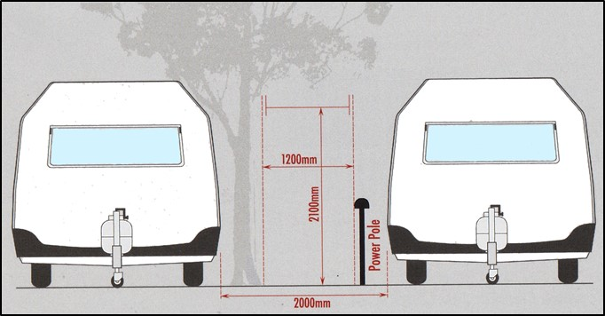

***Figure 5 – Caravan to Caravan***

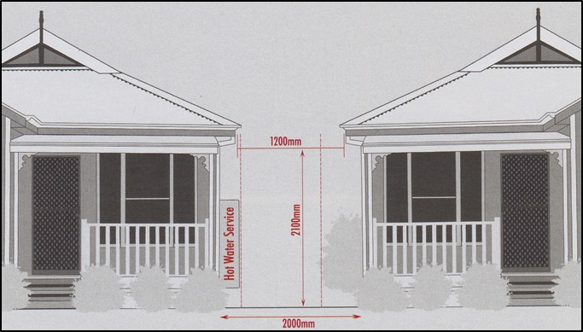

***Figure 6 – Moveable Dwelling to Moveable Dwelling***

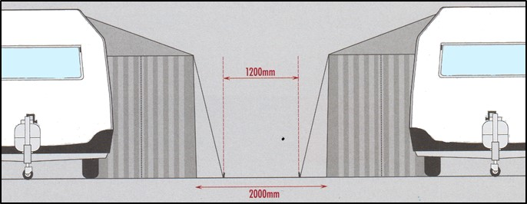

***Figure 7 – Caravan Annexe to Caravan Annexe***

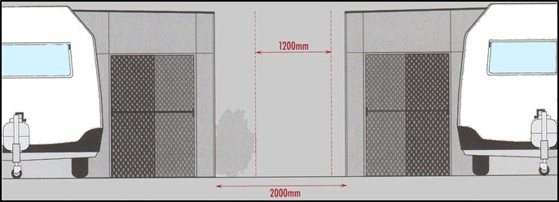

***Figure 8 – Caravan Annexe – Solid Fly to Solid Fly***

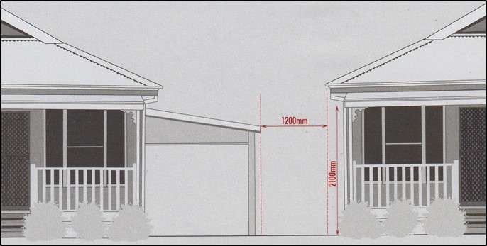

***Figure 9 – Moveable Dwelling to Carport Moveable Dwelling\****

*Note: This configuration is only considered to meet the prescriptive provisions if the carport has 3 sides open and is not fitted with a roller door or any partitions. Otherwise the carport must be a minimum of 2000mm from the external wall of the adjoining structure.

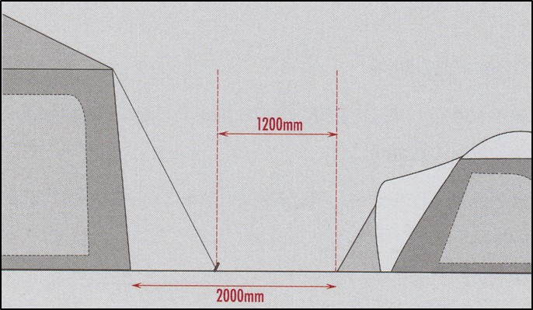

***Figure 10 – Tent to Tent\*\****

**Note: These access and separation distances are required between tent sites, not necessarily individual tents, in order to meet the prescriptive provisions.

***Rationale***

*Firefighter access is required to be provided by the regulations. Additionally, the relevant fire authority consider that fire separation is also required to achieve an appropriate level of fire safety. Research conducted by the relevant fire authority shows that 1200mm width is required for firefighters to operate effectively. This width assumes the worst-case scenario in terms of firefighter maneuverability and tasks (including patient rescue, the use of ladders and fully charged hoses).*

*As caravan parks often have a number of movable dwellings and other permanent structures, there is a trend for movable dwellings to become more home like with occupants staying long term or becoming permanent residents at the park. This can mean that people are living in close proximity to neighbours with a risk of fire spreading to their home.*

*One of the key elements of Building Regulations in Victoria is to protect a dwelling from fire the spread and avoid the spread of fire between dwellings. Movable dwellings, caravans, and tents should be treated no differently. Therefore, the fire separation requirements have been based on the Building Regulations and the Building Code of Australia for class 1a single dwellings, which will allow for the combustibility of typical structures found in caravan parks.*

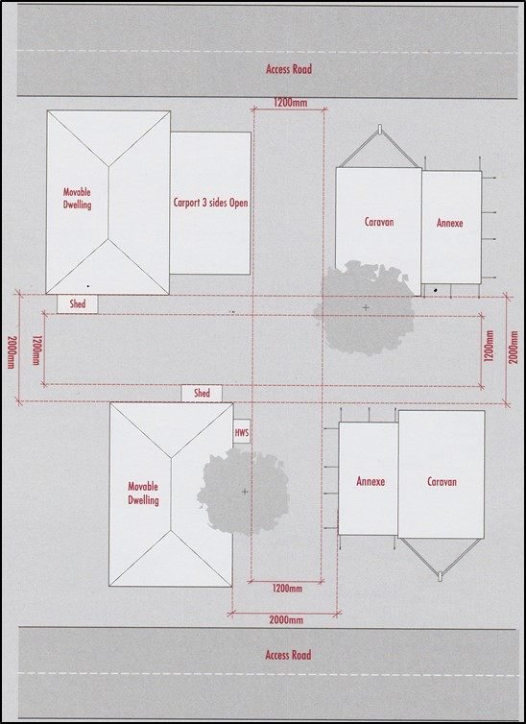

***Figure 11 – Plan view of required firefighter access and fire separation distances#***

#Note: Height clearance of 2100mm must be maintained throughout firefighter access paths.

**PP2 Fire Vehicle Access**

1. Fire vehicle access (in accordance with regulation 21) must be provided within a caravan park as follows:
2. Curves in a driveway must have a minimum inner radius of 10 metres (refer Figure 12 below); and

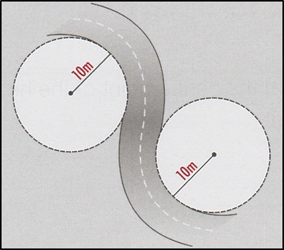

***Figure 12 – Driveway Radius***

1. The average grade must be no more than 1 in 7 (14.4%) (8.1degrees) with a maximum of no more than 1 in 5 (20%) (11.3 degrees) for no more than 50 metres (refer Figure 13 below) and;

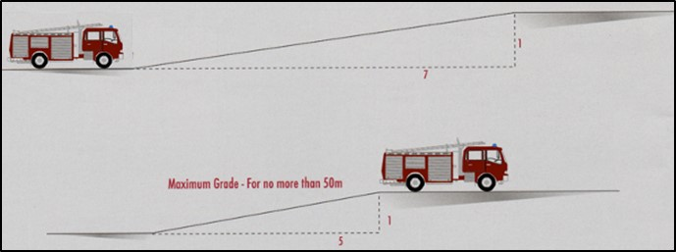

***Figure 13 – Average Grade***

1. Dips must have no more than 1 in 8 (2.5%) (7.1 degrees) entry and exit angle (refer to Figure 14 below); and

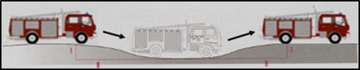

***Figure 14 – Dips***

1. The access road must:
2. Be designed, constructed and maintained for a load limit of at least 15 tonnes, be of all-weather construction; and
3. Provide a minimum trafficable width of 4 metres and be clear of encroachments 4 metres vertically (refer Figure 15); and
4. If the access road is longer than 100 metres from the nearest intersection a turning circle with a minimum radius of 10 metres or:

A “T” or “Y” head with a minimum formed surface of each leg being 8 metres in length measured from the centre point of the head and four metres trafficable width (refer Figure 16) and;

1. If the length of the access road is greater than 200 metres passing bays must be provided. Passing bays must be 20 metres long and be provided every 200 metres with a trafficable width of 6 metres (refer Figure 17).

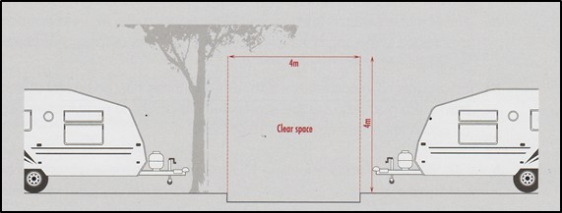

***Figure 15 – Trafficable width and height***

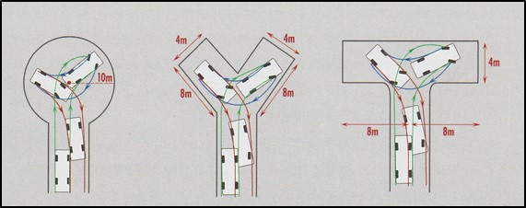

***Figure 16 – Access/Turning circle***

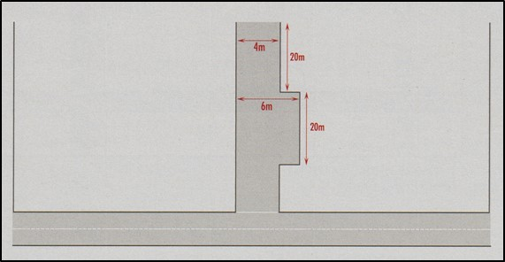

***Figure 17 – Access road length/ Passing bays***

1. To the degree necessary site plans must be provided at every vehicle entrance to the Caravan Park and;
2. be legible at all times; and
3. include:
4. road network and road names; and
5. site layout and numbering; and
6. water supply and hydrant locations; and
7. Road signs are required to be provided.

***Rationale***

*Steep slopes and severe short dips affect the free movement of fire trucks and limit operational capabilities. Roads must be trafficable in all weather conditions and should be constructed to suit a 15 tonne GVM, although most fire trucks weigh less than 13 tonnes however future trucks and some current vehicles weigh more than this amount.*

*It is dangerous for emergency vehicles to back along roads for excessive distances especially in an emergency situation. Access roads must incorporate the ability for fire trucks to execute a 3 point turn safely and permit other emergency services vehicles to pass.*

*Firefighters arriving at a caravan park are often faced with a difficult task of navigating vehicles efficiently to an emergency. Factors include caravan park size, complexity of roads and lack of verifiable information from the caller. Adequate on-site information can overcome this.*

**PP3 Occupant Fire Equipment**

1. Each residential *structure* (excluding tents) within the caravan park must be provided with:
2. Portable Fire Extinguishers selected and installed in accordance with AS 2444 (including signage) maintained to the appropriate standard and be fit for purpose; and
3. Fire Blankets selected and installed in accordance with AS 2444 (including signage) maintained to the appropriate standard and be fit for purpose; and
4. Smoke alarms complying with AS 3786 (these may be battery operated or hardwired) maintained to the appropriate standard and be fit for purpose.

It is acknowledged that caravan park owners may be unable to demonstrate compliance with prescriptive provision PP3 in relation to privately owned caravans. However, private caravan owners should be encouraged to comply with this provision.

1. Each *site* must be provided with:
2. Full coverage from 36m long fire hose reels when fully extended and laid to avoid any physical barriers. Fire hose reels are to be installed in accordance with AS 2441 as if they were being installed to a building and be maintained to the appropriate standard and be fit for purpose (refer Figure 18 below). All fire hose reels must be provided with protection from the weather.

In areas where reticulated water supply is not available static water supply maybe considered to serve fire hose reel systems. Connection may be made to the static water supply provided for the fire service.

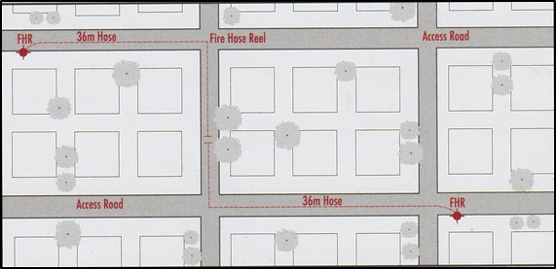

***Figure 18 – Fire Hose Reel (FHR) Coverage***

***Rationale***

*Occupants must be notified of a fire as soon as possible and provided with the opportunity to extinguish it or reduce fire spread prior to the fire services arrival. Occupant Fire Equipment must be reliable and effective. Fire Service response times in regional areas are increased as a function of distance and resources, therefore occupant intervention may be critical in reducing the size of an incident.*

**PP4 Fire Authority Equipment**

A reticulated fire hydrant system is to be provided within the caravan park:

1. So that no more than 120m of hose, laid to avoid all permanent obstructions and anticipated vehicular obstructions will provide coverage to every site and structure (refer Figure 19); and

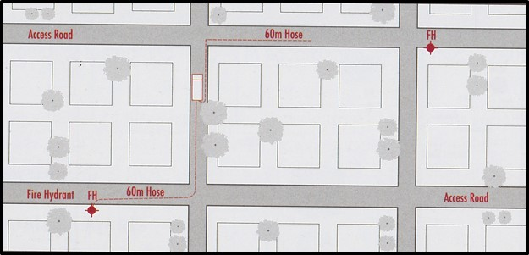

***Figure 19 – Reticulated Fire Hydrant Coverage***

1. To meet the water performance, pipe size and fitting requirements of AS 2419.1-2005 as if they were being installed to protect a building, to the satisfaction of the relevant fire authority; and
2. With external hydrants pursuant to section 3.2.2.2 of AS 2419.1-2005 (refer Figure 20).

***Rationale***

*To support fire brigade intervention, fire hydrants system performance should achieve 10 L/s at 200kPa residual pressure, have dual outlet valves on a 100mm rise and be fitted with couplings to suit the requirements of the local responding fire brigade.*

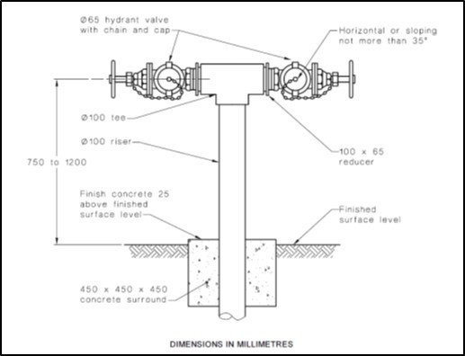

***Figure 20 – External Fire Hydrant pursuant to AS 2419.1***

**OR;**

Static water supply must be provided to the caravan park:

1. With a maintained minimum water supply of 45000 litres exclusively for firefighting use; and
2. To meet the water performance, pipe size, tank construction and fitting requirements of AS 2419.1 as if it was being installed to protect a building, to the satisfaction of fire services; and
3. Located so that every site and structure is within reach of 60m of hose laid from the tank or 120m of hose laid from a hydrant on a reticulated system connected to the tank, to avoid all permanent obstructions and anticipated vehicular obstructions; and
4. With tanks located within 4m of hardstand to allow fire vehicles to connect to the static water supply to the satisfaction of fire services.

Note: For larger caravan parks this requirement may determine that multiple static water supply tanks are required for coverage to be achieved (refer Figures 20 and 21).

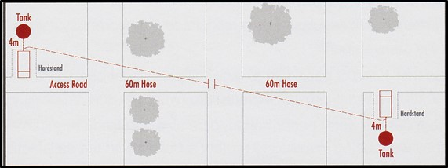

***Figure 21 – Static Water Storage, no reticulation***

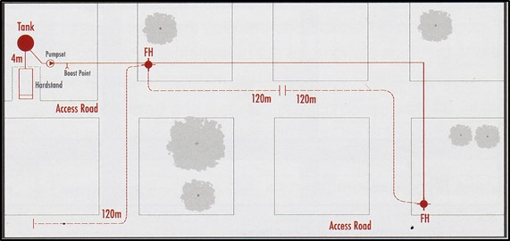

***Figure 22 – Static Water Storage, with reticulation***

***Rationale***

*Fire Hydrants are the most effective means of supplying the high volumes of water required by fire brigades. Although responding brigades may include tankers, the amount of water on such appliances may be insufficient to control or extinguish a fire.*

*Where reticulated water supply is not available, fire brigades may use on site stored water. The prescriptive provision assumes that 45000 litres is sufficient to contain a maximum of 4 caravans / movable dwellings. It also assumes that there will only be one incident at a time. Hence these requirements represent the minimum.*

*The tank is required to supply 10l/s and be fitted with a hard-suction point with full bore isolation valve. The connections required are 150mm-125mm, 125mm-100mm, 100mm-90mm, 90mm-75mm and 75mm-65mm Storz adaptors with a matching blank cap.*

*The 60m figure represents 2 standard hose lengths plus 10m of spray for coverage. Longer lengths create difficulties with set up time, reduce firefighter maneuverability, promote firefighter injury and reduce hydraulic performance.*

**PP5 LP Gas**

LP Gas Storage and use within caravan parks must be in accordance with AS1596, AS5601 and Dangerous Goods (Storage and Handling) Regulations 2000. Information in this regard may be sought from Worksafe.

Caravan Park owners should ensure that any LP Gas cylinders that are used within the parks comply and are inspected regularly. Owners of movable dwellings should also ensure that their cylinders are located in the correct location and secured in such a way that prevents movement.

Clause 4.5.4 of AS1596 – 2008 requires that LP Gas cylinders shall be secured to prevent movement or physical damage. Valves shall be safeguarded against physical damage in accordance with AS 2473.

Clause 4.4.3 of AS1596 – 2008 also sets out the prohibited locations of LPGAS bottles and includes the following.

* + Within a building, except where permitted by AS1596;
  + Under a stairway;
  + In a location with restricted access, where inspection, refilling or exchange of the cylinder is restricted, obscured or hazardous to the operator;
  + Where nearby constructions, fences, walls or vapour barriers could prevent cross ventilation;
  + Under a building, except where permitted by AS1596;
  + Where the cylinder, or an incident involving the cylinder and its contents, could obstruct egress from a building;
  + Buried in the ground, unless the cylinder and gas installation have been specifically designed for such a location.

Acceptable locations for the installation of LP Gas cylinders and the appropriate dimensions required from dwelling features such as door, vents and openable windows. (Refer Figure 23 from AS1596 – 2008).

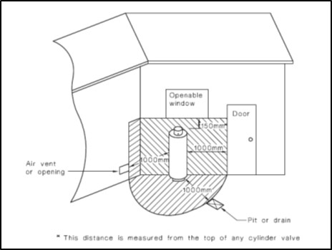

***Figure 23 – Acceptable locations for the installation of LP Gas Cylinders***

**Restriction on Ignition Sources**

As gas bottle are fitted with pressure relief devices and vent discharging pipes it is important that owners understand how these operate and the direction that the bottle may vent.

AS1596–2008 also makes reference to hazardous areas around gas bottles. Caravan park owners must ensure that sources of ignition are not permitted within a hazardous area. (Refer Figure 24 from AS1596–2008).

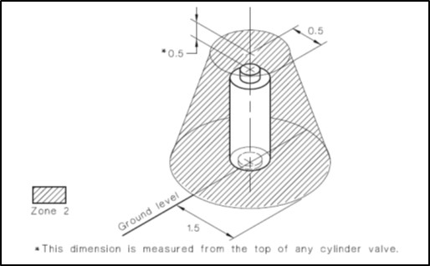

***Figure 24 – Hazardous areas around gas bottles***

**Ignition Source**

An ignition source as defined within AS1596–2008 and is replicated in italics below.

*“…a source of energy sufficient to ignite a flammable atmosphere, including naked flames, smoking, exposed incandescent material, electrical welding arcs, static electricity and electrical or mechanical equipment not suitable for use in the particular hazardous zone”.*

Owners with service equipment such as hot water units, gas or electric, a/c units / condensers, or other spark or piloted equipment should ensure that this equipment is not located within this zone.

Owners who require further information regarding gas safety within a caravan park should contact Energy Safe Victoria.

Caravan parks that store and handle quantities of dangerous goods that exceed those listed under “Manifest Quantity” or “Fire Protection Quantity” in Schedule 2 of the Dangerous Goods (Storage and Handling) Regulations 2000, are required to seek the specific advice of the fire services. Each of the fire services has a Dangerous Goods Unit. This advice may require the implementation of measures exceeding those referenced by this guideline in relation to fire safety equipment. This requirement generally applies to the storage of LP Gas in excess of 5000 litres.

***Rationale***

*LP Gas is a highly volatile liquid and must be stored used appropriately. LP Gas is commonly used in caravan parks and may be stored remotely in large quantities (tank) or smaller cylinders immediately adjacent to accommodation structures. Type, location and orientation of use must therefore be determined to reduce to risk of associated fires.*

**PP6 Electrical Safety**

Rules and AS/NZS 3001-2008 Electrical installations—Transportable structures and vehicles including their site supplies.

The following guidelines should be followed:

1. Power lines must be kept clear of vegetation and other obstructions; and
2. External power supply between the source and structures within the caravan park must be insulated and not contain any connections exposed to the weather; and
3. Supply leads are arranged so that it will not obstruct persons walking in the vicinity of the transportable structure and is either located or provided suitable protection against mechanical damage, damage by high temperatures or ultraviolet radiation;
4. Each site should have its own individual power source; and
5. Each moveable dwelling should have its own Residual Current Device when the movable dwelling is connected to consumer mains power; and
6. The use of multiple power boards and double adaptors should be discouraged; and
7. Extension leads for connection between the external power source and the structure should be tested and tagged in accordance with AS/NZS 3760;
8. where a supply lead is buried and in an area subject to pegs or anchor stakes that exceeding 400mm in length, the supply cable shall be located at a depth of not less than 1.0m or have a continuous pour of concrete placed not more than 75mm above the wiring system, having a thickness of not less than 100mm being not less than 150mm wide overlapping the wiring system by at least 40mm on each side; or an equivalent level of mechanical protection.

***Rationale***

*Electricity is a major cause of fires worldwide. Fires commonly start due the overloading of the power supply by using multiple power boards and or double adaptors. Fires can also start by power lines touching each other as a result of falling trees or branches. Insulation of power supplies is critical to prevent shorting and electrocution. Overloading of power sources can easily cause ignition and contribute to fire starts.*

**Information that the caravan park owner can provide an occupier**

Extract from AS3001 – 2008 Appendix B – Provisions of instruction for caravan park patrons

It is recommended that the caravan park or camping area operators provide all site occupiers intending to connect their transportable structures to the site supply by means of a detachable connection with an instruction notice that conveys the following information:

Only one supply lead shall be connected to each socket-outlet of the site supply.

Any supply lead used to connect a transportable structure to a site supply socket outlet should be in one unbroken length.

The supply of electricity for use in individual transportable structures or vehicles should not be obtained from a socket-outlet inside another transportable structure or vehicle or by the use of socket-outlet adaptors (double adaptors).

Where a supply lead is coiled on or in a reel, drum, storage box or similar, the lead should not be connected to the site supply while coiled.

Electrical installations in transportable structures should be inspected regularly, e.g. annually, by a qualified person to ensure their safe and effective operation.

RCDs used for the protection of transportable structures should be tested by operating the push button on the RCD to check that the device trips. After tripping, the RCD should be reset. If the RCD fails to trip, this failure should be reported to the caravan park manager.

If supply to a site is lost, the device requiring resetting might be located within the premises or at the service pillar.

Although the above information is provided within AS3001-2008 as “informative” and therefore does not form part of complying with the standard, it provides good information that the park owner / manager can use in managing the risks associated with electricity.

Owners who require further information regarding electrical safety within a caravan park should contact Energy Safe Victoria.

**PP7 Flammable Liquids**

Storage and use of flammable liquids within caravan parks must be in accordance with Dangerous (Goods Storage and Handling) Regulations 2000 and AS1940. Guidance should be sought from Worksafe.

Caravan parks that store and handle quantities of dangerous goods that exceed those listed under “Manifest Quantity” or “Fire Protection Quantity” in Schedule 2 of the Dangerous Goods (Storage and Handling) Regulations 2000, are required to seek the specific advice of the fire services. This advice may require the implementation of measures exceeding those referenced by this guideline in relation to fire safety equipment. This requirement generally applies to the storage of flammable liquids in excess of 2500 litres.

***Rationale***

*Flammable liquids are highly volatile and must be stored/used appropriately. Flammable liquids storage areas should be at least 3m away from any dwellings and positioned to prevent a further hazard. Fuels such as petrol and kerosene are heavier than air and will therefore settle in low spots such as drains. Caravan park facilities should also be equipped with a means of handling small spills with a non-leaching, biodegradable oil and chemical absorbent.*

**PP8 Emergency Management Plan**

Pursuant to regulation 22 of the Residential Tenancies (Caravan Parks and Movable Dwellings Registration and Standards) Regulations 2010, Emergency Management Plans must be developed for each caravan park. Emergency management plans should be developed in accordance with AS 3745 and AS/NZS 4360.

AS1596 and AS1940 also have a requirement for the provision of Emergency Management Plans as does the Dangerous Goods (Storage and Handling) Regulations 2000 where the storage thresholds are met. These standards and regulations impose greater information and consideration than that required by AS3745. Therefore, each caravan park should investigate whether or not any additional obligations exist under AS1596, AS1940 or the Dangerous Goods (storage and handling) Regulations 2000.

Emergency management plans must be prepared in consultation with the relevant emergency services. Caravan Park owners will need to engage all the relevant services.

The Emergency Management Plan must be located in a prominent position that is acceptable to all of the emergency services but will generally be the park main office.

Each of the emergency services including the Fire Services can provide assistance in the development of appropriate Emergency Management Plans.

Display of Emergency Warnings

The regulations require (Regulation 24) a caravan park owner must display a copy of any public emergency warnings on any day that the warning is current, it must be displayed in a prominent position in—

* The caravan park office; and
* Every building in the caravan park that contains communal facilities; and
* Any other place determined by the council.

On receiving an emergency warning for example, “Code Red” for bushfires, the caravan park owner must implement the relevant emergency procedures in accordance with the emergency management plan.

***Rationale***

*An emergency management plan is an essential part of fire safety in any facility containing multiple, unrelated occupants. Emergency situations are always time critical and efficient actions provide positive results. However, emergency management plans must be site specific.*

*Bushfire risks in caravan parks are obviously increased in regional areas and emergency management plans must take account of this. The extent of bushfire risk is subject to a number of variables. These include surrounding vegetation, topography, location in relation to manageable land and site boundaries, site access and brigade resources.*

*Sound emergency management plans must assess all risks associated with the caravan park. Risks associated with the storage and handling of Dangerous Goods should also be accounted for appropriately by Emergency Management Plans.*

# OTHER GUIDANCE INFORMATION

## Provisions for Maintenance

Maintenance is essential is to ensure that fire prevention and safety equipment, access and separation will perform at the same level of operation that existed at the time of installation and or commissioning.

Throughout the regulations and this guideline, the provision of maintenance is included and must be undertaken to meet the Performance Measures and comply with the Regulations.

Regulations 20and 21 require that the provision of fire prevention and safety - equipment and access and separation are provided and maintained.

Division 4 of the Regulations (Regulations 43 – 46) generally require that movable dwellings are maintained:

* In working order
* In a good state of repair
* In a clean, sanitary and hygienic condition.

Regulation 46 also requires park owners and the short-term occupier must keep the site clean and free of anything or substance that may affect the health and safety of other persons.

***Rationale***

*Reasons for ensuring maintenance of various fire safety equipment could be general wear and tear, reliability of a system operating and any faults after commissioning of a system.*

*Fire prevention and safety systems need to be maintained at a level of performance specified, usually by an Australian Standard, through periodical inspections and checks or other specified method. Records of the maintenance inspections and checks provide proof of maintenance and should also be kept.*

*Where fire safety systems are not maintained the risk to the park owner increases. For example, if the fire services cannot find the hydrant, as the garden bed is overgrown or location signage is missing, valuable time is lost trying to locate the hydrant increasing the risk of fire spread.*

Maintenance is dependent on the complexity of the equipment and the experience of the person carrying out the inspection. Where appropriate some equipment may be maintained by the owner, more complex systems, such as hydrants and hose reels will need to be serviced by a service installer, maintenance contractor or internal maintenance personnel.

Where the owner appoints a person to undertake the maintenance, they must ensure that the person is appropriately qualified and competent to undertake the work.

Therefore, a qualified and licensed person can only undertake such work. Where other tasks can be carried out by a ‘competent person’ who does not have formal qualifications, such a person must still be able to demonstrate they have the necessary training, qualification or experience, (or a combination of them), to carry out the inspecting and testing task in a competent manner.

***Rationale***

*A competent person is a person who has acquired – through training, qualification or experience (or a combination of them) – the knowledge and skills enabling the person to perform the task correctly. In the context of this manual, that person would need to be competent in inspecting, testing and fire safety systems. Whoever is responsible for ensuring a particular task is carried out must determine that the person engaged to carry out that task is competent to do so.*

*In determining a person’s competency, due consideration must be given to their qualifications, the training they have received relevant to the task at hand, and their previous experience in doing similar tasks. Some tasks, for example electrical or plumbing installation, inspection and testing, will require a particular competence, such as a formal qualification and/or license.*

Generally, the nature and frequency of maintenance is not prescribed within these guidelines or the regulations because it will vary greatly depending on the type of equipment, its age and the conditions under which it operates.

However, advice maybe sought from the relevant fire authority or other suitably qualified person, such as building surveyors (Private or Municipal), services engineers, essential safety measures maintenance providers, on maintaining fire safety systems within the caravan park. Generally, this advice will be based on documentation such AS1851-2012. Caravan park owners should also document the items that are required to have regular ongoing maintenance. In preparing the list, caravan park owners should seek advice from the persons nominated above in determining a reasonable level of maintenance and the inspection frequencies.

## Specific Advice on Smoke Alarms (Regulation 36)

Smoke alarms in movable dwellings should be tested by the park owner at the change of each occupier. Any owner of a movable dwelling within a caravan park must also ensure that the smoke alarms are in working order if they hire the movable dwelling to a short-term occupier.

## Maintenance and inspection records

Although the Regulations do not specify any level of documentation to be kept by the owner, FRV and CFA recommend that maintenance records be retained on site in a physical form and available to organisations such as FRV, CFA, Council and insurers on request.

Any maintenance records should contain the following information:

* Record reference.
* Name and Address of Caravan Park.
* Date of maintenance/inspection.
* System or equipment identification and location (Possibly a location plan).
* Frequency of maintenance activity undertaken.
* Defects identified.
* Name of property owner or the agent.
* Name and signature of the service person.
* Date the record was completed.

Maintenance records may be electronically based or in the form of “logbooks”. Hard copy records may be prepared utilising electronic recording systems and such technology is designed to deliver an accurate, accountable, consistent and timely level of service. As technology in regard to the preparation of maintenance records has advanced considerably in recent years with the advent of purpose-designed software, park owners may want to consider over time adopting electronic record keeping helping manage the maintenance of fire safety systems.

## Maintenance Inspection Frequencies

The following tables (Tables 2-6) provide some basic levels of maintenance for fire safety systems. This table represents only those items nominated within this guide and does not override or replace maintenance determinations that may have been issued in accordance with other legislation. This frequency nominated in this table is the minimum and frequencies may need to be increased and / or varied as a result of the environment in which the systems are operating in. For example; foreshore caravan parks may need to have more frequent maintenance as a result of the corrosive sea air environment has on equipment.

Caravan park owners will need to consider the appropriate safety system and equipment listed that is installed in their caravan park. Some of the systems and equipment listed may not apply. The tables do not require that any equipment be installed, but provides some guidance to the level of maintenance where these systems are installed in a park

Table 2 – Firefighter Access and Separation

|  |  |  |
| --- | --- | --- |
| **Essential safety measure to be inspected or tested** | **Installation standards/ level of performance** | **Nature of inspection or test and Frequency of inspection or test** |
| Fire Fighter Access | Caravan park fire safety guidelines | **Annual inspection** to ensure that clearance and access has been maintained. That no storage of materials has occurred within the fire separation requirements. |

Table 3 – Fire Vehicle Access and Navigation

|  |  |  |
| --- | --- | --- |
| **Essential safety measure to be inspected or tested** | **Installation standards/ level of performance** | **Nature of inspection or test and Frequency of inspection or test** |
| Fire vehicle access | Caravan park fire safety guidelines | **Annual inspection** to ensure that clearances and access has been maintained. No obstruction occurred and roadways are in good order. |
| Fire vehicle navigation aids | Caravan park fire safety guidelines | **Annual Inspection** to ensure that signage and other aids are in approved locations and in good working order. |

Table 4 – Fire Separation

|  |  |  |
| --- | --- | --- |
| **Essential safety measure to be inspected or tested** | **Installation standards/ level of performance** | **Nature of inspection or test and Frequency of inspection or test** |
| Fire Separation | Caravan park fire safety guidelines | **Annual Inspection** to ensure that separation has been maintained as approved. That no storage of materials has occurred within the fire separation requirements. |

Table 5 – Fire Equipment

|  |  |  |
| --- | --- | --- |
| **Essential safety measure to be inspected or tested** | **Installation standards/ level of performance** | **Nature of inspection or test and Frequency of inspection or test** |
| Fire extinguishers (portable) | AS 2444  (As published at the time of installation) | As per AS1851 Maintenance of Fire Protection System and Equipment  (As published at the time of installation) |
| Fire blankets | AS 2444  (As published at the time of installation) | As per AS1851 Maintenance of Fire Protection System and Equipment  (As published at the time of installation) |
| Fire hose reels | AS 2444  (As published at the time of installation) | As per AS1851 Maintenance of Fire Protection System and Equipment  (As published at the time of installation) |

Table 6 – Fire Authority Equipment

|  |  |  |
| --- | --- | --- |
| **Essential safety measure to be inspected or tested** | **Installation standards/ level of performance** | **Nature of inspection or test and Frequency of inspection or test** |
| Fire hydrants | AS 2419.1  (As published at the time of Installation) | As per AS1851 Maintenance of Fire Protection System and Equipment  (As published at the time of installation) |
| Static water storage | Caravan park fire safety guidelines  AS 2419.1  (As published at the time of Installation) | As per AS1851 Maintenance of Fire Protection System and Equipment  (As published at the time of installation) |

# CHECKLIST

This checklist can be used by park owners as a simple check to identify any issues that they may need to address. This may be by seeking further advice, or it may help a park owner identify those issues that may need to be addressed through the emergency management planning and a suitable risk treatment process.

The layout provided will enable park owners answer the points raised and provide an area for comments to be made. The checklist is based on the prescriptive provisions but allows an owner to make comment where needed. Parks will need to be careful as this list is indicative only and will require the park owner to ultimately read the guideline to make a reasonable judgment regarding compliance.

**Provision for Maintenance and Access**

* + Fire Fighter Access – compliant access provided?
  + Fire separation – compliant separation provided?
  + Vegetation – managed between and around structures?
  + Storage – managed between and around structures?
  + Fire vehicle access – maintained and trafficable?
  + Site plans – provided at all vehicle entries show roads, hydrants and water supply?

**Prevention of Fire Spread**

* + Portable Fire extinguishers – correct type selected, installed?
  + Fire Blankets - correct type selected and installed?
  + Smoke Alarms – installed?
  + Hose reels – installed 36m hose. Do they provide coverage to all areas?

**Provisions and Maintenance of firefighting Equipment**

* Fire hydrant system – installed?
  + Does it provide coverage to all areas?
  + Do they hydrants meet the external hydrant requirement?
  + Does the system meet the water performance requirement (10 Litres/s at 200kPa) needed?
* Static Water Supply – is it required if the water performance cannot be met?
  + Do the tanks have hardstand area for fire vehicles?
  + Can the tanks provide a minimum water supply of 10l/s?

**Identification and management of fire hazards**

* + - LP Gas – Cylinders installed and secured correctly?
  + Are they vented away from the structure?
    - Electrical Safety – Is the external power supply compliant?
  + Are the supply leads arrange correctly?
  + Are the leads used to connect to power tagged?
  + Are RCDs installed in structures?
  + As the park owner, have I provided information about electrical safety to park occupants?
* Flammable Liquids – Do I have any fire protection quantities or Manifest quantities of flammable liquids?
  + Has any advice been sort from FRV or CFA about these quantities?
  + Are fuels stored in a manner as not to cause a further hazard?

**Development and implementation of Emergency management Plans**

* Emergency Management Plans – is and EMP available
  + Has it been developed based on agreed templates by the emergency services?
  + Does it address all of the issue identified?
  + Has it been supplied to council?

**Other Guidance Information**

* + - Maintenance – Are the fire safety systems being maintained on a regular basis?
  + Are logbooks available as proof?
  + Are smoke alarms regularly checked to ensure operation?

**Compliance with the legislative requirements**

* As a caravan park owner, have I met all of the legislative requirements?
  + Do I have a fire safety audit report prepared by the relevant fire service?
  + Do I have an EMP that is update?
  + Have I supplied these to council as part of my registration application?
  + Am I meeting my registration obligations?
  + Am I maintaining my fire safety equipment installed within the park?

# REFERENCES

|  |
| --- |
| * Australian Standard 1596-2014 “The storage and handling of LP Gas” |
| * Australian Standard 1851-2012 “Maintenance of Fire Protection Systems and equipment” |
| * Australian Standard 1940-2017 “The storage and handling of flammable and combustible liquids” |
| * Australian Standard 2419.1-2005 “Fire hydrant installations – system design, installation and commissioning” |
| * Australian Standard 2441-2005 “Installation of fire hose reels” |
| * Australian Standard 2444-2001 “Portable fire extinguishers and fire blankets – selection and location” |
| * Australian Standard 3001-2008 “Electrical installation – Transportable structures and vehicles including their site supplies |
| * Australian Standard 3745-2010 “Emergency control organisation and procedures for buildings, structures and workplaces” |
| * Australian Standard 3786-2014 “Smoke alarms” |
| * Australian and New Zealand Standard 3000-2018 “Electrical installations (known as Australian / New Zealand Wiring Rules)” |
| * Australian and New Zealand Standard 3001-2008 “Electrical installations – relocatable premises (including caravans and tents) and their site installations” |
| * Australian and New Zealand Standard 3760-2010 “In-service safety inspection and testing of electrical equipment” |
| * Australian and New Zealand Standard 4360-2004 “Risk Management” |
| * National Construction Code Series 2019 |
| * Fire Rescue Victoria Act 1958 |
| * Country Fire Authority Act 1958 |
| * Dangerous Goods Storage and Handling Regulations 2000 |
| * Planning and Environment Act 1987 |
| * Residential Tenancies Act 1997 |
| * Residential Tenancies (Caravan Parks and Movable Dwellings Registration and Standards) Regulations 2020 |
| * Department of Planning and Community Development – Guide to Victoria’s Caravan Park Regulations, 1 December 2010 |

***Note:*** *this is a controlled document and may only be modified by authorised FRV personnel.*